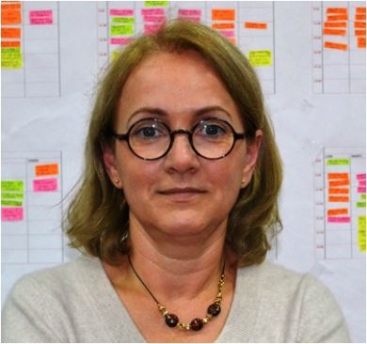

Marinela BURADA

Marinela Burada is a tenured Professor in the Department of Theoretical and Applied Linguistics at Transilvania University of Brașov, Romania.

She holds a Ph.D. in Indo-European Linguistics from the University of Bucharest, Romania, where she defended her dissertation on the role played by Latin in the historical development of the English language.
She earned a Master’s degree in Education at the University of Manchester, U.K., with a thesis in the field Contrastive Rhetoric. In 2016 she earned her habilitation degree, which, in the Romanian system, certifies the holder’s qualifications to act as doctoral advisor.
Her teaching, research, and supervisory work has been conducted in areas subsumed under the domains of Linguistics, Academic Literacy, and Lexicography. She authored and co-authored articles, book chapters, monographs, and textbooks on topics relating to contact linguistics, L1 academic writing practices, and monolingual lexicography.

